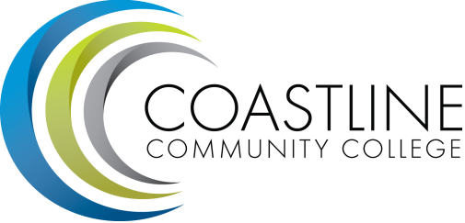

Classified Senate Meeting Agenda
Thursday, June 18, 2015
Noon to 1:30 pm
4th floor conference room, College Center

Luncheon for outgoing and incoming Classified Executive Committee

